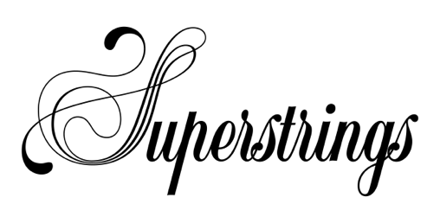
Easter Festival 2021
Market Lavington Community Hall
Thursday 15th and Friday 16th April 2021

Pupil Name:
Parent/Guardian:
Date of birth:
Address:
Tel no (home):
Tel no (mobile):
Email:
Instrument:
Last grade taken and pass mark:
Current repertoire:
Any other information that might affect your child’s learning:
Name of Teacher:
I enclose a £110 cheque
OR
I will pay £110.00 directly via BACS to CAF Bank Ltd, Acc. 00017067, Sort code 40-52-40 Ref: ‘Child’s Name’

Please return to:
Caroline Kaneen, Jasmine House, 33 Oxford Street, Aldbourne, SN8 2DQ. Tel: 01672 541507.
Email: admin@superstringsclub.co.uk

